There are two general options for protecting sensor cables.

One option uses the type of flexible metal conduit manufactured for electrical wiring. The other uses a specialized material called "sleeving".

The conduit option is less expensive in total parts, but adds complexity in acquiring the various different parts, and in assembly. The sleeving option is more expensive but far simpler, and saves weight in the finished units.

The conduit option, general diagram:

Data logger

Junction box, takes up slack in sensor cables

Cables go through conduit to sensors

The major parts (and weight) for the conduit option are the PVC junction box, and the flexible metal electrical conduit ("flex conduit"). These will be covered below.

Additional details of the conduit option:

Data logger

Junction Box

1

1

2

2

3

3

The design requires:

1. Short lengths of sleeving (see below) to protect sections of sensor cables not feasible to enclose in conduit.

2. End connectors on flex conduit, to protect sensor cables from sharp conduit edges.

3. Metal hose clamps for mounting on to frame, to support substantial weight of flex conduit.

The sleeving option, general diagram:

Data logger

The sleeving option is much simpler. Each sensor cable is enclosed in sleeving from the datalogger to the sensor end. The only issues are selecting the correct diameter of sleeving, cutting the sleeving, and putting the sensor cables through the sleeving. These will be covered below. Sleeving is light weight enough to be held on to the frame by twist ties.

Default option, no protection:

Data logger

You may decide you do not need cable protection if your deployment will not be susceptible to gnawing animals.

Construction details for the option using flex conduit:

The core of this option is a PVC "junction box", of the type used for electrical connections. The National Electric Code requires all junctions of wires be within a box, thus the name. However, in this design it is just a name. Nothing is actually "joined" inside the box; it's for taking up the slack in cables.

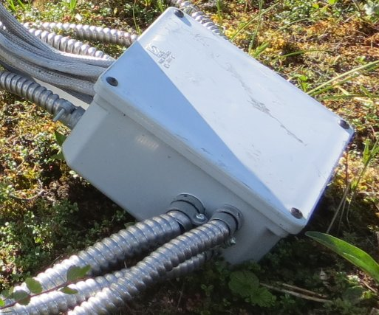  
Junction box and conduit

The cable ends go in and out of the box through numerous conduits. These are the spiraled silver-colored tubes in the picture above. The idea of "protection" is that no part of any cable is anywhere exposed, vulnerable to gnawing animals.

The more braided-looking tubes to the left in the picture above are sleeving, which we will discuss later.

We tried various junction boxes, and settled on item number 8261K27 from McMaster-Carr (http://www.mcmaster.com/). This box is about 9 x 9 inches square and about 5 inches deep. This large size provides plenty of room for cables inside, and also plenty of wall area for conduit entries (explained below).

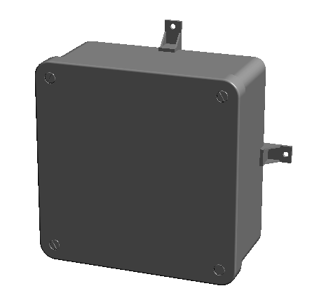  
McMaster-Carr,  
part number 8261K27

The plastic tabs on the edges are provided to mount the box on a flat surface such as a wall. These tabs are attached to the box by screws tapped into threaded holes on the back of the box. We did not use these tabs, but put the screws through holes in the mantis frame bar, and directly into the holes on the back of the box.

The screws are 1/4"-20 size (the screw shaft is 1/4" diameter and has 20 threads per inch). Four screws come with each box, so you do not need to buy them separately. The center-to-center hole distance is 7-5/8", symmetrically, both side-to-side and top-to-bottom. This is the distance apart that holes in the mantis frame need to be, to match the box. A suitable size for holes in the mantis frame is 5/16" diameter.

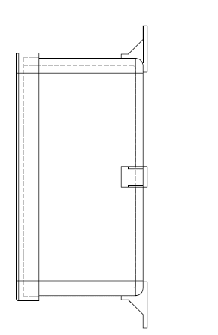  
The box comes with tabs for wall mounting.

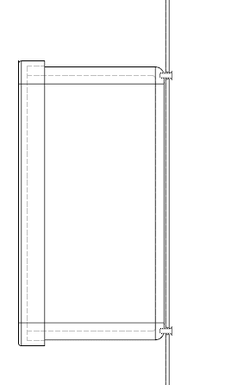  
However, we used screws directly in the tab holes, from the back.

For cable protection, we used two commonly available sizes of flex conduit. We used mostly "half-inch", but needed "three-quarter inch" for a few of the sensors. These conduit sizes are what is known as "nominal" or "trade size". This means that the stated size (e.g. "half inch") is a label that refers to a standardized size. It does not exactly correspond to any particular dimension of the component such as inside or outside diameter.

The connectors that mate with the conduit are specified in the same way, so a "half inch" end connector is the correct one for "half inch" conduit.

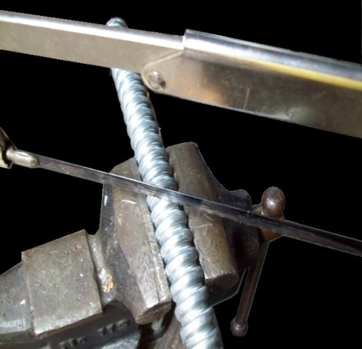  
  
Cutting flex conduit

This is the recommended method for cutting flex conduit. Half inch conduit is shown. You hacksaw diagonally across the "bulge" of the spiral and then the two pieces will screw apart. There is also a technique where you bend the conduit sharply to "crack" the spiral where you want to divide it, and then cut the remaining metal strip with tin snips.

The cut ends of metal conduit are sharp. The National Electric Code requires that all wires passing through metal conduit exit through end connectors, and this is a good idea for these sensor cables too. A cable draping across a sharp edge can gradually have its insulation cut through by tiny motions such as daily thermal expansion. End connectors hold the enclosed cable away from sharp edges.

For flex conduit, there are two common types of end connectors. The screw-in connector shown on the left below has threads along its shaft that simply slip inside along the flex conduit spiral. The squeeze connector on the right below has a metal band that clamps around the outside of flex conduit when you tighten the screw.

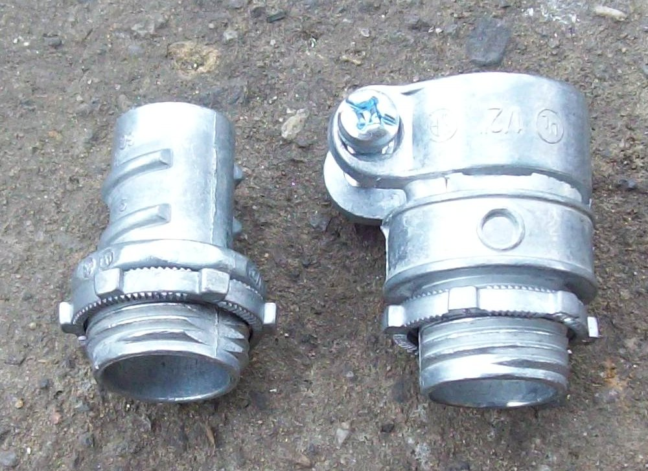  
  
We recommend the squeeze-on type connector, to the right.

Although the squeeze connectors are larger and have the added complexity of the screw, we recommend them for this design because they allow more working room inside.

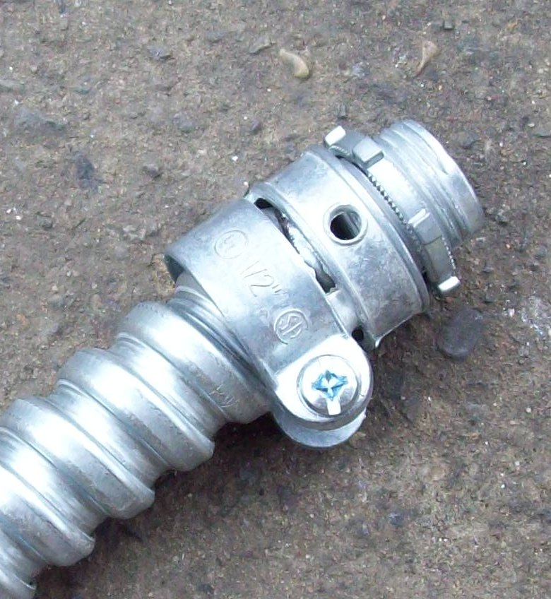  
Squeeze connectors fit over the conduit.

You will mount the connectors in the wall of the junction box. The inset below shows how.

You take the ring off the threaded end of the connector, put the threaded end through a hole, and then screw the ring back on to hold the connector in place.

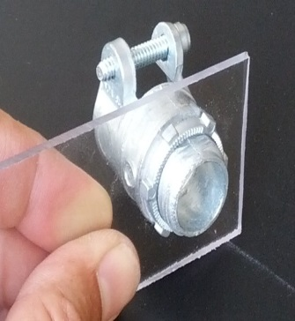  
  
Connector mounting, demonstrated using Plexiglas.

The ring should be tight enough that it will not allow the connector to work loose. You can tighten it with pliers, by tapping it tight with a screwdriver, or by twisting the main body of the connector to screw it tighter into the ring.

In use, the threaded ring will be towards the inside of the junction box, and the main body of the connector will be outside.

For half inch connectors you will need to drill 7/8" diameter holes. A 3/4" diameter hole is not quite big enough.

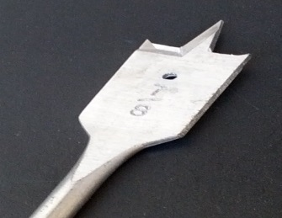  
  
A 7/8" spade bit is the size for half inch (nominal) connector holes.

For three-quarter inch (nominal) connectors, you will need 1 1/8" diameter holes.

A spade bit, as shown to the right, works well to drill through the PVC box wall.

You may have to drill quite a number of holes through the box walls for all your sensor cables. The diagram below illustrates how to get the maximum number of useful holes. The dimensions are for the 7/8" diameter holes for "half-inch" connectors, which most of the holes will be. You will need a smaller number of 1 1/8" diameter holes for "three quarter inch" connectors. Use the same principles, but vary the dimensions.

You will also drill 1/2" diameter holes for the lines between the junction box and the logger (described later). These can be as close together as feasible because they will only have sleeving going through them and will not need conduit connectors.

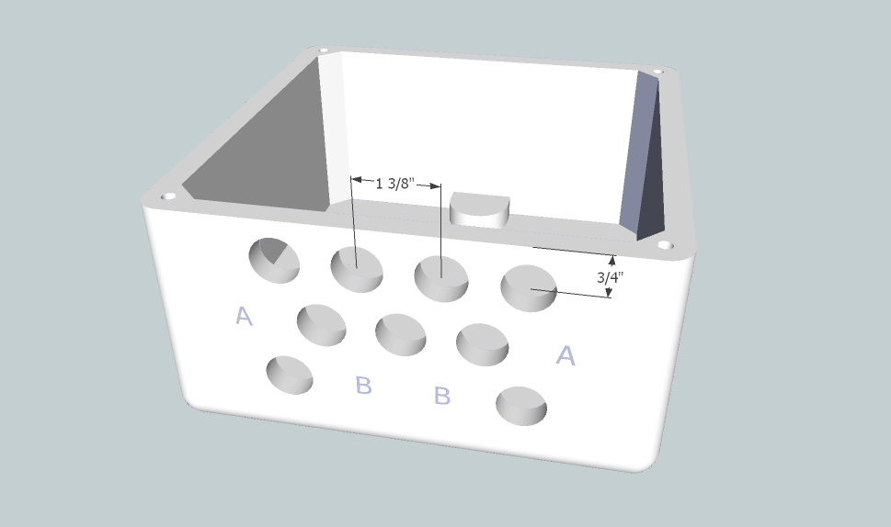

* Center holes no closer than 3/4" from the box opening, to allow screwing on the lid.
* Center holes at least 1 3/8" apart from each other, to allow for the end connector hardware.
* Stagger the courses of holes rather than using a square pattern. This allows more holes to fit in the box wall.
* Positions A: Avoid holes here if possible. Hardware can run into the interior bevels.
* Positions B: Avoid holes here. Hardware can run into the internal screw mount bases.

Cables inside the junction box, and within conduit, are well protected. However, small lengths of cables are exposed between the ends of the conduit and the sensors themselves (this might not be obvious until you are constructing one of these units). In addition, the lines between the Hobo data logger case and the junction box are not feasible to protect with conduit because the cables exit the logger in a relatively tight cluster.

If cable protection is compromised anywhere, and a cable gets chewed through, it spoils the run of the entire cable. We tried various materials, such as wire screen, to protect cables at their tight points. The solution we chose was a specialized material called "sleeving". We have only found it available from McMaster-Carr.

Sleeving is something like wire mesh, but with the strands crossing diagonally so as to form a tube. We used sleeving made of stainless steel to avoid any problems with corrosion as well as animal damage.

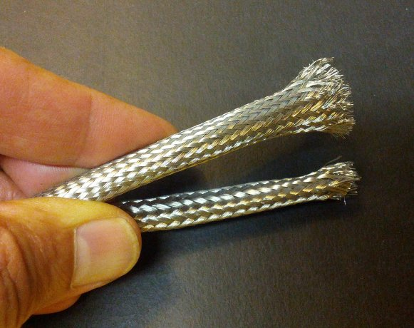  
  
Sleeving: 1/4" below, 3/8" above.

Sleeving expands in girth when shortened and becomes narrower when pulled long ways. The stated diameter is evidently the width when drawn to its narrowest. Because of this, it may not be obvious what size sleeving you may need, to fit over any particular object. We will give the sizes we used below. It is always possible that suppliers (here, Onset Computer Corp) may change the design of components (here, the sensors the sleeving goes over), so we suggest you obtain a few feet of various sizes to try before committing to a major order.

You cut sleeving with tin snips, but not all models are able to sever the sleeving. Some tin snips only mash the sleeving strands. We suggest you take samples of sleeving to a hardware store and try various tin snips, to make sure to get one that can cut the material.

To put things in concrete terms, we will give a comparison of mantis designs using conduit vs. sleeving. This is *primarily* conduit vs. *all*-sleeving because, as discussed, even the "conduit" design requires some sleeving.

The schematic for this example is on the following page. This example is the same as the "station" mantis design described in the Instrumentation section. It uses a Hobo U30 data logger, and a solar panel to keep the Hobo battery charged. It uses one each of Solar Radiation and PAR sensors. It uses an air temperature/air relative humidity sensor, which is a single physical sensor having both of these functions combined in it. The design has *two* sets of soil moisture and soil temperature sensors, as might be used in heterogeneous terrain such as arctic tussock tundra.

You may use different numbers and types of sensors, but the example shown here should allow you to adjust the calculations.

Parts list:

|  |  |  |
| --- | --- | --- |
| Item | part number | supplier |
| Data logger* | Hobo U30 | Onset |
| Solar panel* | SOLAR-6W | Onset |
| Solar Radiation sensor* | S-LIB-M003 | Onset |
| PAR sensor* | S-LIA-M003 | Onset |
| Air temperature / humidity sensor* | S-THB-M002 | Onset |
| Soil temperature sensor* | S-TMB-M006 | Onset |
| Soil moisture sensor* | S-SMC-M005 | Onset |
| Flex conduit, half inch | 5502-30-00 | Home Depot |
| End connector for above | 2192B3 | Home Depot |
| Flex conduit, three quarter inch | 5503-30-00 | Home Depot |
| End connector for above | 2193B3 | Home Depot |
| Junction box | 8261K27 | McMaster |
| Hose clamp | 5362K16 | McMaster |
| Sleeving, 1/4" diameter | 1478T1 | McMaster |
| Sleeving 1/2" diameter | 1478T3 | McMaster |

* These items are not part of the cable protection cost estimates, but are included here for complete illustration of the design.

Suppliers:

Onset = Onset Computer Corp, http://www.onsetcomp.com/

McMaster = McMaster-Carr, http://www.mcmaster.com/

Home Depot = Example. These parts would be available from many hardware suppliers, in this case http://www.homedepot.com/

Schematic of this example design

Hobo U30 Data logger

Junction box

PAR

Solar rad

Air temp/Rh

Soil temp 1

Soil moist 1

Soil temp 2

Soil moist 2

Solar panel

PAR sensor

Solar radiation sensor

Air temperature / relative humidity sensor

Soil temperature sensor 1

Soil temperature sensor 2

Soil moisture sensor 1

Soil moisture sensor 2

In the "conduit" option: The lines between the data logger and the junction box go through short lengths of sleeving. The lines that go from the junction box to the sensors go through conduit most of the way, except for short lengths of sleeving at the sensor ends.

In the "sleeving" option: The junction box does not exist. The lines from the data logger to the sensors go through sleeving all the way. Sometimes they go through different diameters of sleeving for different parts of their length.

In both options, the cable from the data logger to the solar panel goes through sleeving.

To assemble cable protection, one or both of the sensor ends are "fished" through sleeving and/or conduit. The detailed examples below illustrate all the issues with conduit and sleeving.

The irradiance sensors for PAR (S-LIA-M003) and Solar Radiation (S-LIB-M003) are physically the same. The sensor end is a blocky cylinder about an inch in diameter. The other end of the cable has a clip, as shown.

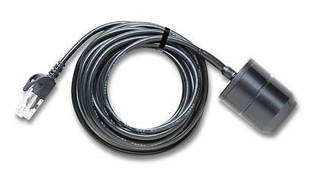Irradiance sensor.  
(Image © Onset Computer Corp)

For the conduit option, you would first put the clip end through a 5" length of 1/2" diameter sleeving, and bring this sleeving all the way up to the sensor head. This sleeving will serve as protection of the far end of the cable, which bends too tightly to cover with conduit.

Assemble conduit connectors onto both ends of a 60" length of half inch flex conduit. This length allows placing the irradiance sensor at the "head" of the mantis. Install one end of the conduit into the junction box using the threaded ring, as previously illustrated with Plexiglas. The other connector will be free near the sensor. This connector on the free end prevents the sharp edges of the conduit from damaging the cable insulation. Sharp, unprotected conduit ends would also be very hazardous to handle in the finished equipment.

sleeving

Data logger

Junction box

sleeving

flex conduit

conduit connector

This diagram shows the general idea. The 60" length of conduit is appropriate for the size mantis frame given in the Framework section. For the irradiance sensors, you would bring the conduit out the "top" of the junction box, to have a fairly straight run to the mantis head. The entire setup has many more lines going in and out of the junction box than shown in this diagram.

On completion, the cable runs from the irradiance sensor head through a short length of sleeving, then through the main length of conduit, and into the junction box. From the junction box, the clip end of the cable goes out of the junction box through a 1/2" hole, through a 10" length of 1/2" diameter sleeving, and to the data logger. The extra length of cable is coiled up inside the junction box.

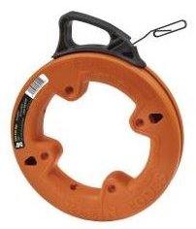  
Electrician's   
"fish tape".

An electrician's tool known as a "fish tape" is useful for pulling the clip ends of the sensor cables through conduit.

The cut ends of the sleeving tend to splay, with the sharp points of the wires poking out. This discourages gnawing animals, but can also stab unwary human fingers.

For the "all sleeving" option, the sensor cable simply goes through 1/2" diameter sleeving all the way from the irradiance sensor head to the data logger. There is no junction box. You do not need any tools to bring the cable end through the sleeving. You just keep working it until it's through. The cable is 3 meters long, so this takes somewhat more than 10 feet of sleeving. In our tests, the needed length was 124 inches.

At this point you may wish to skip ahead and glance at the "cost comparison" table that lays out the details of the conduit vs. sleeving options. You can see that the PAR and Solar Radiation sensors, being physically identical, need the same protection parts. The other sensors have somewhat different requirements, as we will discuss now.

The soil temperature sensor (S-TMA-M006) has a cylindrical "lump" in the cable. In the "conduit" option, this will be inside the junction box.

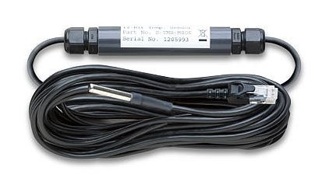Soil temperature sensor  
(Image © Onset Computer Corp)

You would bring the clip end of the cable out of the junction box and to the data logger through a 10" length of sleeving, the same as for the irradiance sensors.

The other end, the small silvery cylinder, which is the temperature sensing end, goes out of the junction box through a length of conduit, similarly to the irradiance sensor.

sleeving

Data logger

Junction box

sleeving

flex conduit

conduit connector

In this case, since the sensor needs to reach the soil, the conduit should come out the side or "bottom" of the junction box. We used a conduit length of 68", as the soil moisture sensors were to be in proximity to the other instrumentation.

We used a short length (6") of sleeving on the sensor end, to avoid temperature interference from the conduit. Since the sensor end is so slim, it would fit through 1/4" diameter sleeving.

For the "all sleeving" option, most of the cable (84") could go through the less expensive 1/4" sleeving. This was the slim sensor end, and the cable running up to it from the "lump". The other end, the clip end, required 24" of 1/2" diameter sleeving, to cover the "lump".

The combined air temperature / relative humidity sensor works essentially the same as the soil temperature sensor, with the differences shown in the cost comparison table. The sensor was up on a stake, so we used a longer length (16") of sleeving on the sensor end so as to have less of the heavy conduit weighing that end down.

The Onset soil moisture sensor has a broad forklike end.

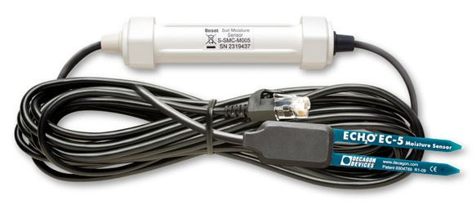  
Soil moisture sensor.  
(Image © Onset Computer Corp)

For the "conduit" option, this requires three-quarter inch (nominal) flex conduit out from the junction box for this sensor end to fit through, instead of the half inch (nominal) that is big enough for the other sensors. The large white cylindrical "lump" goes inside the junction box, as before.

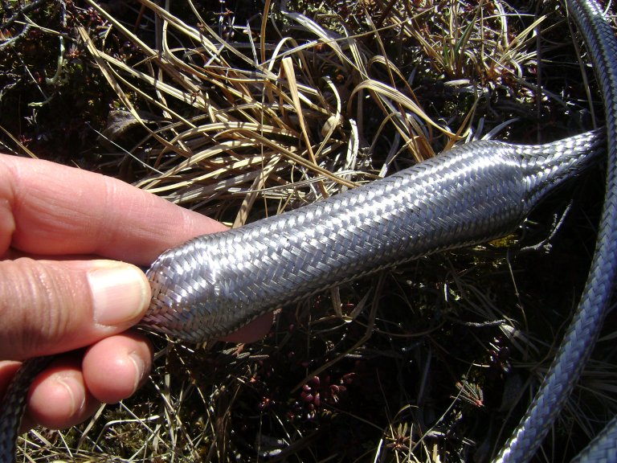  
  
Sleeving over the moisture sensor "lump".

The "all sleeving" option requires 1/2" diameter sleeving for the entire length, to fit over the "lump".

Cable protection, cost comparison of "flex conduit" option vs. "sleeving" option.

|  |  |  |  |  |  |  |  |  |  |  |  |  |  |  |
| --- | --- | --- | --- | --- | --- | --- | --- | --- | --- | --- | --- | --- | --- | --- |
|  | whole unit | Solar panel | PAR sensor | Solar rad sensor | Soil moist 1 | Soil moist 2 | Soil temp 1 | Soil temp 2 | Air temp / RH | totals | unit cost, high | unit cost, low | total cost, high | total cost, low |
| **Conduit option,** (total mantis weight 34 pounds) | | | | | | | | | | | | | | |
| flex conduit, 1/2" nom, linear inches |  |  | 60 | 60 |  |  | 68 | 68 | 52 | 308 | 0.0675 | 0.0433 | $20.79 | $13.35 |
| flex conduit, 3/4" nom, linear inches |  |  |  |  | 68 | 68 |  |  |  | 136 | 0.0917 | 0.0575 | $12.47 | $7.82 |
| conduit end, 1/2", ea. |  |  | 2 | 2 |  |  | 2 | 2 | 2 | 10 | 0.77 | 0.77 | $7.70 | $7.70 |
| conduit end, 3/4", ea. |  |  |  |  | 2 | 2 |  |  |  | 4 | 1.127 | 1.127 | $4.51 | $4.51 |
| 1/2" dia sleeving, linear inches |  | 33 | 15 | 15 | 15 | 15 | 10 | 10 | 10 | 123 | 0.238 | 0.185 | $29.32 | $22.76 |
| 1/4" dia sleeving, linear inches |  |  |  |  |  |  | 6 | 6 | 16 | 28 | 0.175 | 0.136 | $4.90 | $3.80 |
| hose clamp | 2 |  |  |  |  |  |  |  |  | 2 | 1.688 | 1.688 | 3.38 | 3.38 |
| PVC junction box | 1 |  |  |  |  |  |  |  |  | 1 | 43.63 | 43.63 | $43.63 | $43.63 |
| Total costs: high, low |  |  |  |  |  |  |  |  |  |  |  |  | **$126.68** | **$106.94** |
|  | | | | | | | | | | | | | | |
| **Sleeving option,** (total mantis weight 28 pounds) | | | | | | | | | | | | | | |
| 1/2" dia sleeving, linear inches |  | 33 | 124 | 124 | 224 | 224 | 24 | 24 | 24 | 801 | 0.238 | 0.185 | $190.91 | $148.19 |
| 1/4" dia sleeving, linear inches |  |  |  |  |  |  | 84 | 84 | 84 | 252 | 0.175 | 0.136 | $44.10 | $34.23 |
| Total costs: high, low |  |  |  |  |  |  |  |  |  |  |  |  | **$235.01** | **$182.42** |

High cost estimates are based on single unit purchases, low cost estimates include bulk discounts (2010 prices).

The following page is a picture of a mantis (deployed in tundra) built using conduit for cable protection.

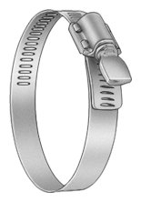  
  
Thumb screw hose clamp.

One of the details difficult to see is how the conduit for the irradiance sensors is held on to the mantis frame. We used stainless steel hose clamps. We chose a model of hose clamp that uses a thumb screw to tighten, and therefore does not require any tools.

Two of these hose clamps were sufficient for mounting the irradiance sensor conduit on each mantis; one near the mantis "head" and one near the main frame cross junction.

You could mount this conduit using nylon cable ties. However the nylon become brittle from ultraviolet light after a few months in sunlight, and easily breaks.

We found we often had to make minor adjustments in the field, and so an easily removable mount was useful. These were the same hose clamps used for the irradiance sensor collimators (see the Instrumentation section), so they were already incorporated in the design.

The only source we know of for these thumb-screw hose clamps is McMaster-Carr. In the overall project, we used two sizes of these hose clamps. The smaller was part number 5362K16, the larger 5362K18. We used the smaller to hold on the collimators, and this was also the size to hold the flex conduit onto the mantis frames for most of the mantises.

These were the mantises that had only two irradiance sensors, and so had only two parallel lengths of flex conduit along the mantis neck.

A few of the mantises, the "reference" mantises monitoring ambient sky irradiance as well as irradiance reflected up from the ground, had four irradiance sensors, and therefore four parallel lengths of flex conduit along the neck. These additional conduits required the larger size hose clamps.

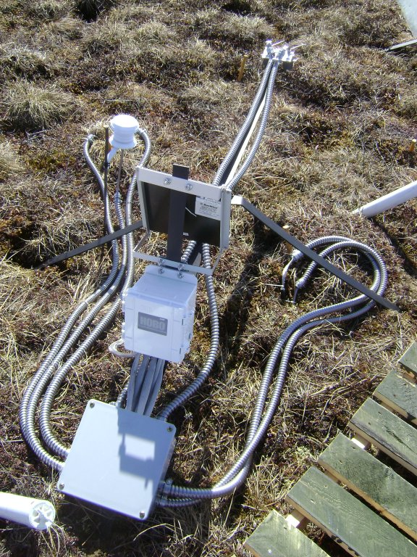

Mantis built using mostly flex conduit for cable protection.

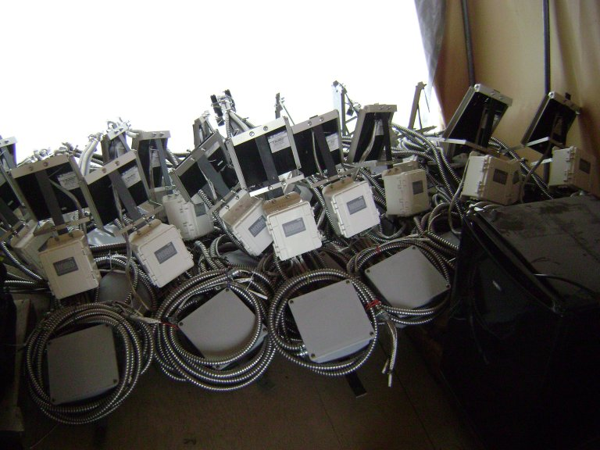

The picture above shows mantises stored for winter. The conduit lengths are neatly coiled up. The easiest way we found of holding the conduit in coils was with short, 6" bungee cords.

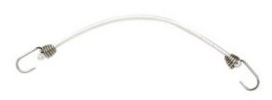  
6" bungee cord

This also makes it much easier to carry these mantises to and from field sites. Otherwise, the long runs of heavy conduit swing around, and drag and catch on things.

We recommend 3 or 4 bungees per mantis. For remote fields sites, it's good to think ahead and have these on hand before deployment or retrieval. Also, communicate with field personnel, who may throw away the bungees, not realizing what they are for when not in use.

The following page shows a mantis built using all sleeving for cable protection.

The sleeved cables are bundled using cable ties. We later came to prefer twist ties after we learned of the nylon sunlight embrittlement. Twist ties area also easier to field adjust.

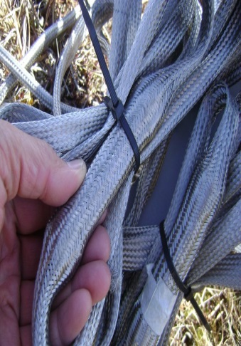  
  
Bundled sleeving.

Such twist tie material is available in the gardening section of hardware stores. It is used to tie plants up on trellises and is inexpensive. You can often find it as a coil, so you can cut pieces to any needed length.

The twist ties are also sufficient to hold the lightweight sleeved cables onto the mantis frame.

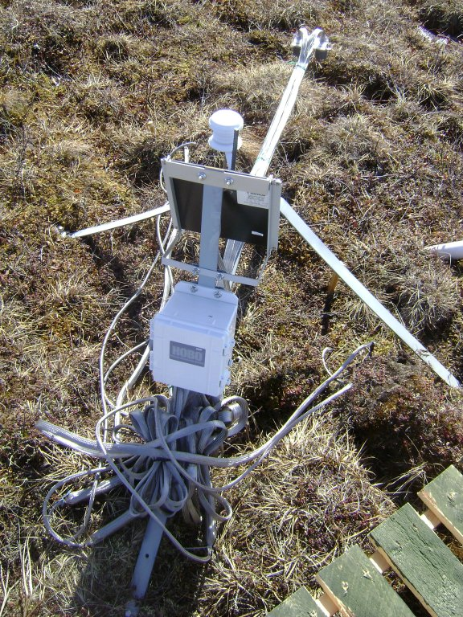

Mantis built using all sleeving for cable protection.

Summary, comparing "conduit" vs. "sleeving" cable protection options:

The "sleeving only" option costs more in materials, mostly because of the long cables of the soil moisture sensors. Balanced against this are:

* Simplified construction: Using conduit requires cutting and keeping track of three different lengths of two different diameters of conduit. It requires drilling many holes in the junction box, of four different sizes, in carefully placed patterns. Any rework, by patching and re-drilling holes in the junction box, is time consuming and problematic. The "conduit" option requires mounting the junction box, by precisely dimensioned and spaced holes in the steel straps of the mantis frame, and there is no practical way to change this later.
* Simplified procurement. The "conduit" option required large numbers of conduit end connectors, of two different sizes. For our project using 22 mantises, these were problematic to acquire, cleaning out the inventory of three Home Depot stores.
* Flexible sensor placement. The "conduit" option locks in the maximum distance sensors can be away from the data logger. The "sleeving" option allows placing them out to the maximum length of their cables.
* Weight and space saving. A "conduit" mantis weighs 34 pounds. A "sleeving" mantis weighs 27 pounds. The 7 pounds saved and elimination of the bulky junction box makes a "sleeving" mantis much easier to carry.